Fall Newsletter September 2016

ST. MARTIN’S CHURCH NEWS

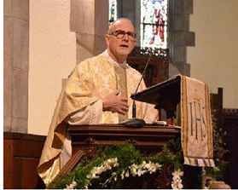
From the Rector
Welcome back! I trust that those of you who have had a chance to get away over the summer have returned refreshed and ready for the start of another cycle of work, school, and church. It’s odd that the calendar year runs from January to December, but the significant rhythm to our lives actually runs from September through June.
This autumn, the catchword I want to give you is investment. You know the saying, “it takes a village to raise a child”. Well, it requires investment by each and every one of us to raise a healthy, vibrant and spiritually anchored community. We are an every member ministry parish. This means there is no illusory other person to do that which we are not willing to do. We – individually and as a community – are fed and nourished only through the extent of our mutual investment. Through investing ourselves in our common life, we are fed through nurturing our relationship with God and with one another. Investment makes us magnetic; and we begin to attract others to our community because it’s exciting to be around committed people invested in a common vision.
We ended our very successful program year in 2015-16 with an end of year story. In it we identified our milestone achievements and immediate challenges going forward. We noted three key priority areas emerging from our engagement with the RenewalWorks program: embedding the Bible in parish life, engaging our passions, and the heart of leadership as the priorities guiding our future. The video of the end-of-year story can be viewed online at stmartinsprov.org.
We begin the 2016-17-program year on September 11 continuing the theme of story with a Beginning-of-the-Year Story that will identify our Table of Contents (see attached calendar) for the coming program year. A special
Build-your-own Bagel Coffee Hour will follow the 9:30am service.
Join us. It’s an exciting time to be at St Martin’s!

Mark+

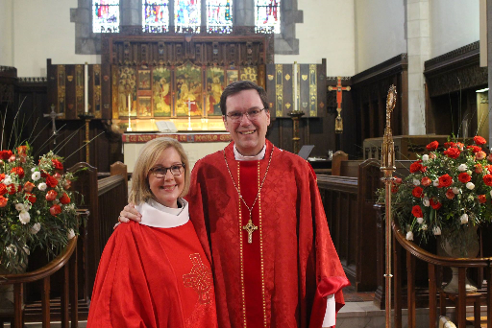

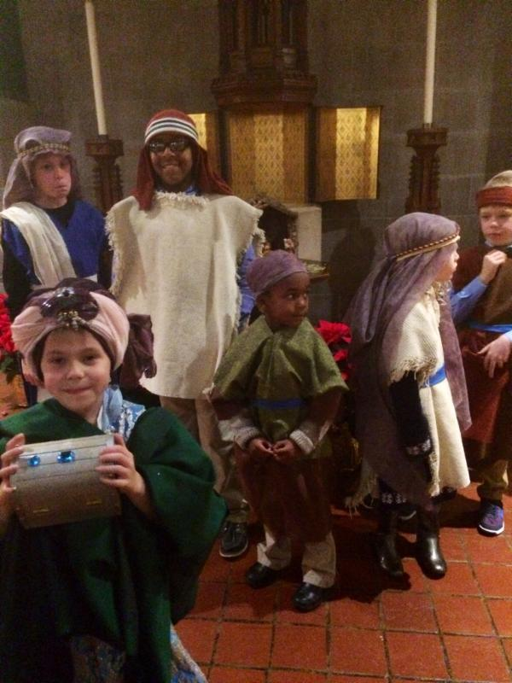
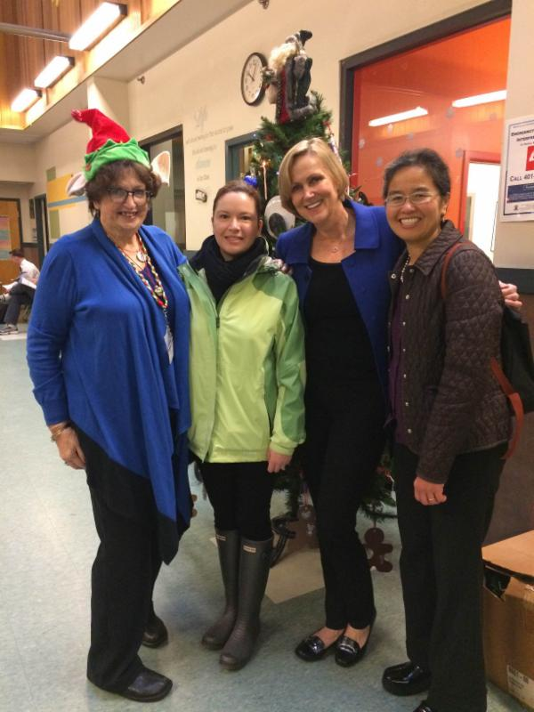
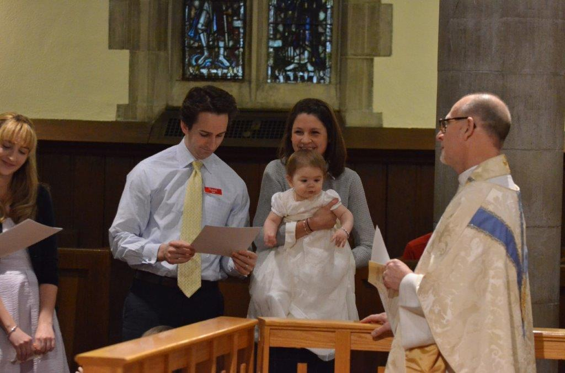

St. Martin’s Story: “Table of Contents”
FALL 2016
NOVEMBER
Sunday, November 6
Daylight Savings Time ends
Friday, November 11
Veteran’s Day - office closed
Saturday, November 12
Bead Workshop 9am
Sunday, November 20
Advent Outreach Project Launch
Celebrate St. Martin’s – the next 100 years!
Patronal Evensong 4:30pm
Unveiling of the new altar followed by
Potluck Supper
Tuesday, November 22
Interfaith Service at St. Martin’s 7pm
Reception will follow
Thursday, November 24
Community Thanksgiving Dinner 1pm
Friday, November 25
Office closed
Sunday, November 27
Advent Festival with Wreath-making
Pageant Sign-ups
For more details, visit our website or call the office.

SEPTEMBER
Monday, September 5
Labor Day - office closed
Wednesday, September 7
The Thrifty Goose reopens 10am-2pm
Thursday, September 8
Adult Choir rehearsals resume 7:30pm
Sunday, September 11
Beginning-of-the-Year Story
8am Eucharist
9:15am Nursery
9:30am Sung Eucharist
Welcome our new Minister of Music Nick Voermans
10:45am “Build-your-own Bagel” Coffee Hour
Followed by short programs for adults and children (KidZone)
Tuesday, September 13
Women’s Spirituality Group 6pm
Gander 7pm
Sunday, September 18
Youth Breakfast at 9:30am
‘Make your own Breakfast Taco’ Grades 6-12
Tuesday, September 20
Temple-Church Conversation
Temple Beth-el 7pm
What do we believe, and how does this shape the way we feel about the current of civic debate in America?

OCTOBER
Sunday, October 2
Blessing of the Animals!! 4pm
Friday, October 7
TGIF at 6pm
Mingle with friends over hors d’oeuvres after a busy week!
Monday, October 10
Columbus Day - office closed
Thursday, October 20 - Saturday, October 22
Icon Workshop
Instruction by Iconographer Peter Pearson
Sunday, October 23
Annual Stewardship Campaign begins
St. Martin’s Episcopal Church
50 Orchard Avenue
Providence, RI 02906
(401) 751-2141 www.stmartinsprov.org
DECEMBER
Saturday, December 3
Advent Tea & Entertainment 4pm
The Carol of the Bell?
“A winter’s tale of a purloined G#”
Sunday, December 4
St. Nicholas visits the KidZone!
Wednesday, December 21
Blue Christmas Service of Darkness & Light 5:30pm
Saturday, December 24
Christmas Eve Services 4pm & 9pm
Pageant during 4pm service
Sunday, December 25
Christmas Day Service 9:30am

